ROTARY CLUB OF HASSAN
Rotary International — District 3181

MINUTES OF MEETINGS
Rotary Year 2026–27
RI Theme: "Creating Lasting Impact"
Team AIKYAM
MEETING 5
Expert Session on "Sukha–Dukha"

Date | 30 July 2026
Venue | Rotary Suvarna Bhavan, Hassan
PROCEEDINGS
The meeting was called to order by President Rtn. Dr. Geetha Kiran A.
The President welcomed the members and introduced the guest speaker, Dr. H. L. Mallesh Gowda, Retired Professor of Kannada and President of the District Kannada Sahitya Parishat, Hassan. She highlighted his distinguished academic career, literary contributions, and dedication to promoting Kannada language and culture.
Dr. Mallesh Gowda delivered an engaging and thought-provoking expert session on "Sukha–Dukha" (Happiness and Sadness). He explained that happiness and sorrow are integral parts of human life and emphasized the importance of maintaining emotional balance during both joyful and challenging times.
Drawing from literature, philosophy, and everyday life, he shared numerous real-life examples to illustrate how people's perspectives influence their experiences of happiness and suffering. He encouraged members to cultivate resilience, gratitude, compassion, and positive thinking while facing life's inevitable challenges. His inspiring talk prompted meaningful reflection among the participants and was highly appreciated by all present.
The President thanked Dr. Mallesh Gowda for sharing his wisdom and enriching the members with valuable life lessons.
The meeting concluded with the Vote of Thanks proposed by Rtn. Sunitha Somashekar, Secretary.
PHOTOGRAPHS
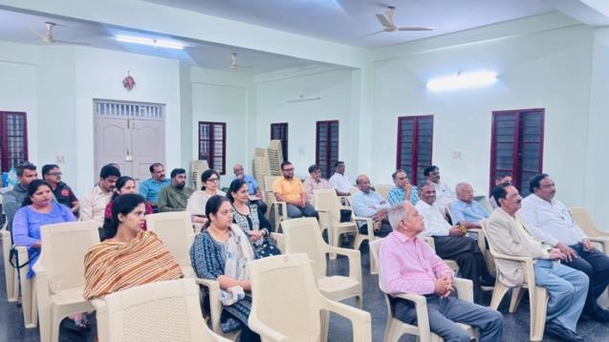 | 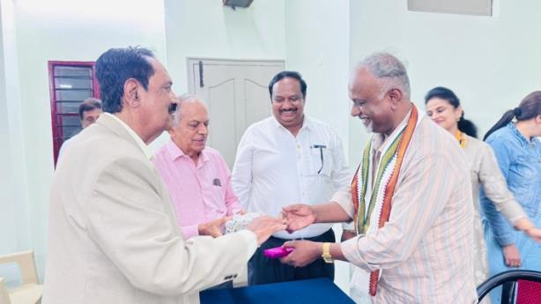

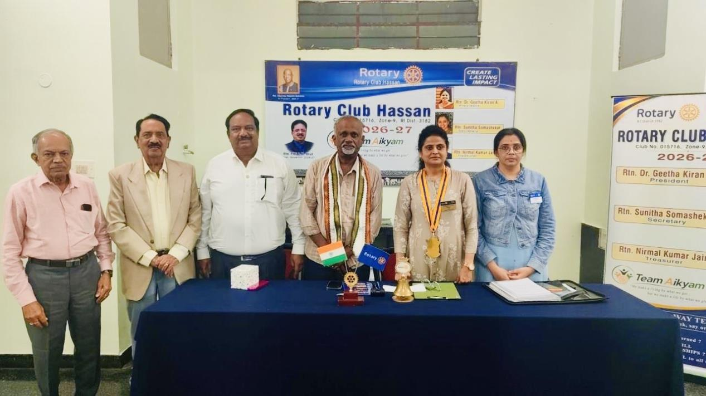
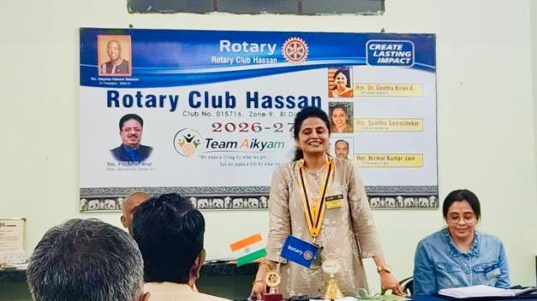 | 